|  |  |
| --- | --- |
| **Experiment Number** | **03** |
| **Date of Experiment** | 04/09/2023 |
| **Date of Submission** | 11/09/2023 |
| **Name of the student** |  |
| **Roll Number** |  |
| **Section** | ECS-01 |

**Aim of The Experiment :-**

Overview of LabVIEW for signal processing and design & determination of frequency, amplitude and phase of various types of signals using LabVIEW

**Equipment and Software Required:-**

The Equipment and Software required are as follows:

LabVIEW

**Block diagram:**

**Numeric operations to two input values**

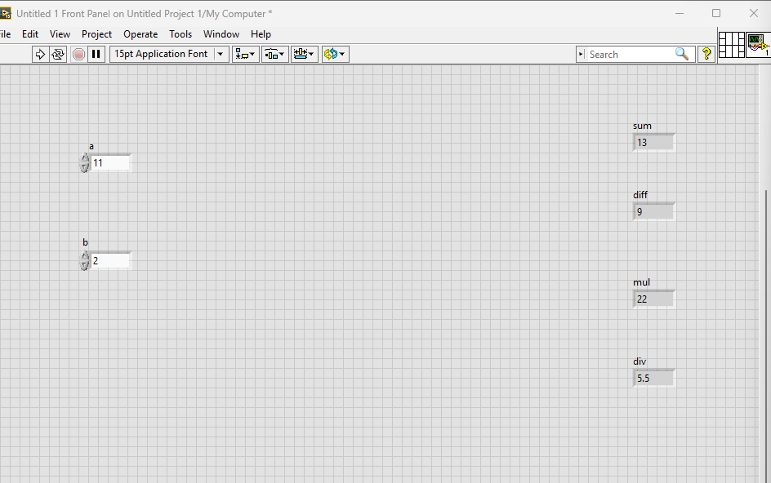

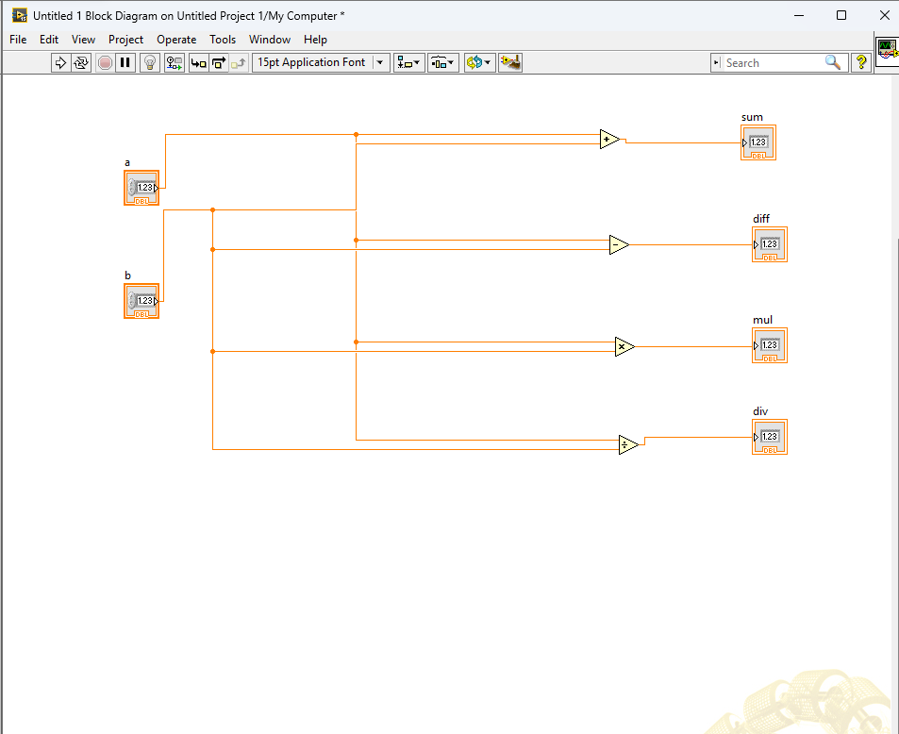

**Conversion of Celsius scale to Fahrenheit and vice versa**

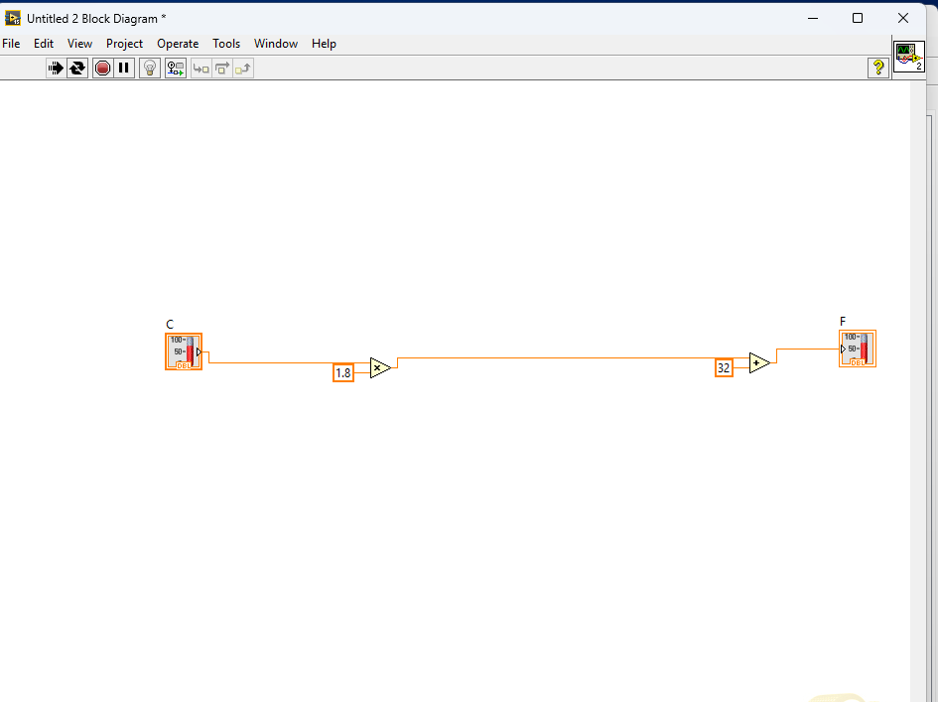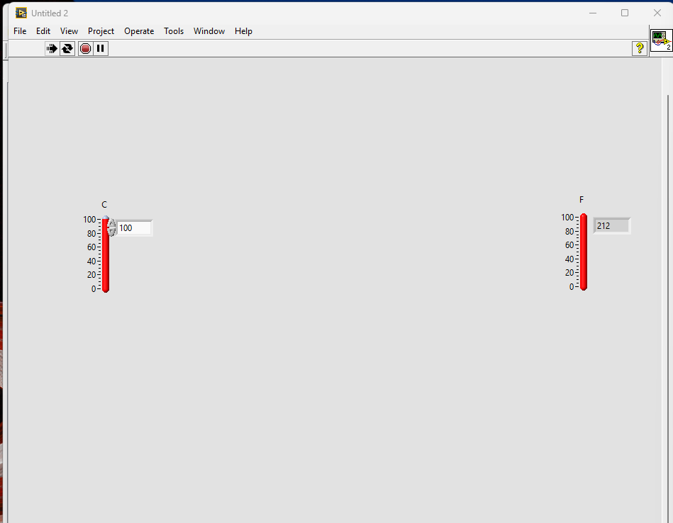

**Formation of sine ,aquare and triangle waveform using phase amplitude and frequency input(**

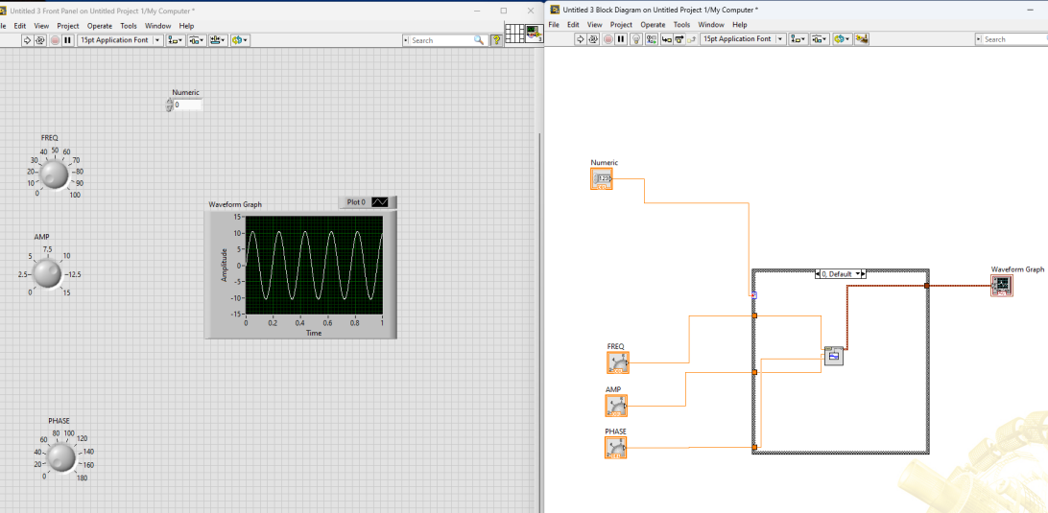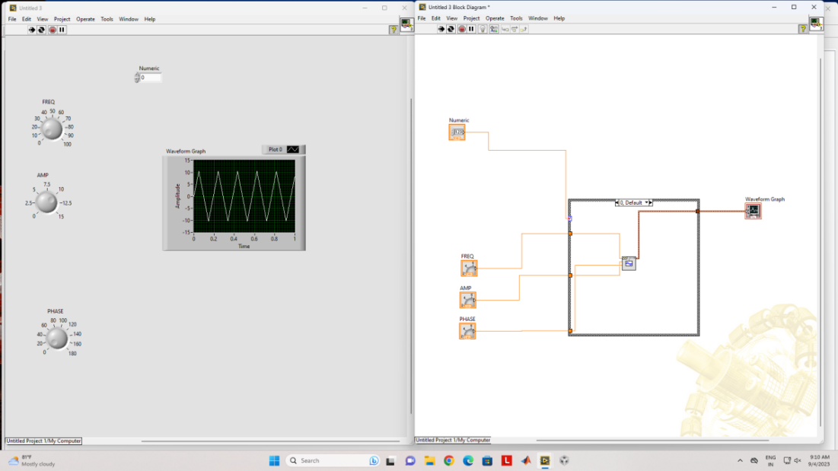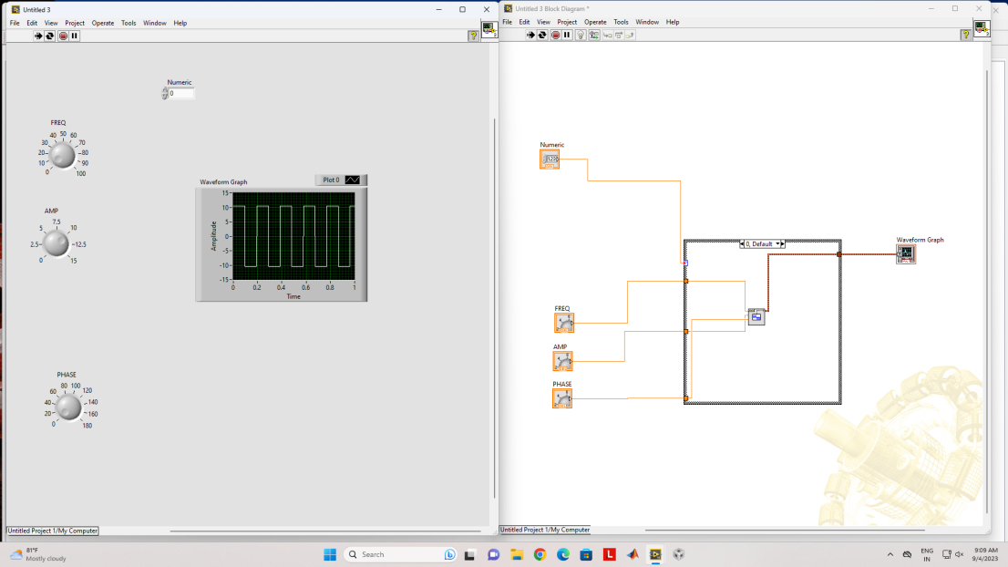

**Discussion or Inference of the experiment:**

From this experiment we made a circuit for doing numeric operations (like addition, subtraction, multiplicaition and division) on 2 input values, we converted celcius to farenheit and vice versa ,generated sine wave square wave and triangle wave by putting in phase , frequency and amplitude value -using LabVIEW.

**Conslusion:**

This experiment taught us how to create VI’s using LABview, how to use numeric operations ,use structures, wiring , generate waveform and give different type of inputs (using knobs and entering the value etc),etc .